Part I: Research Question

Note: Your responses to the task prompts must be provided in a document file. Unless otherwise specified, responses to PA requirements that are included in a Python or RStudio notebook will not be accepted.
A. Select one of the scenarios and describe the purpose of this data analysis by doing the following:
1. Provide one research question that you will answer using neural network models and computer vision techniques. Be sure the research question is relevant to a real-world organizational situation related to the images, video, and audio captured in your chosen dataset.
How can a neural network classify plant seedlings into 12 species categories to assist botanists in distinguishing crop seedlings from weeds for better crop management?
2. Define the objectives or goals of the data analysis. Be sure each objective or goal is reasonable within the scope of the research question and is represented in the available data.
Preprocess the data set, train a neural network, evaluate the models performance using metrics like accuracy and F1 score
3. Identify an industry-relevant type of neural network capable of performing an image, audio, or video classification task that can be trained to produce useful predictions on image sequences on the selected dataset. Convolutional neural network (CNN)
4. Justify your choice of neural network in part A3. CNNs are highly effective for image classification tasks due to ability to extract spatial features from image .
Part II: Data Preparation
Note: You may use Python or R for implementing your coding solutions, manipulating the data, and creating visual representations. However, your responses to the task prompts must be provided in a document file. Unless otherwise specified, responses to PA requirements that are included in a Python or RStudio notebook will not be accepted.
If you selected the Image Dataset:
B. Describe the data preparation process by doing the following:
1. Perform exploratory data analysis on the chosen image dataset and provide screenshots of the following:
a. visualization for the distribution of the different classes
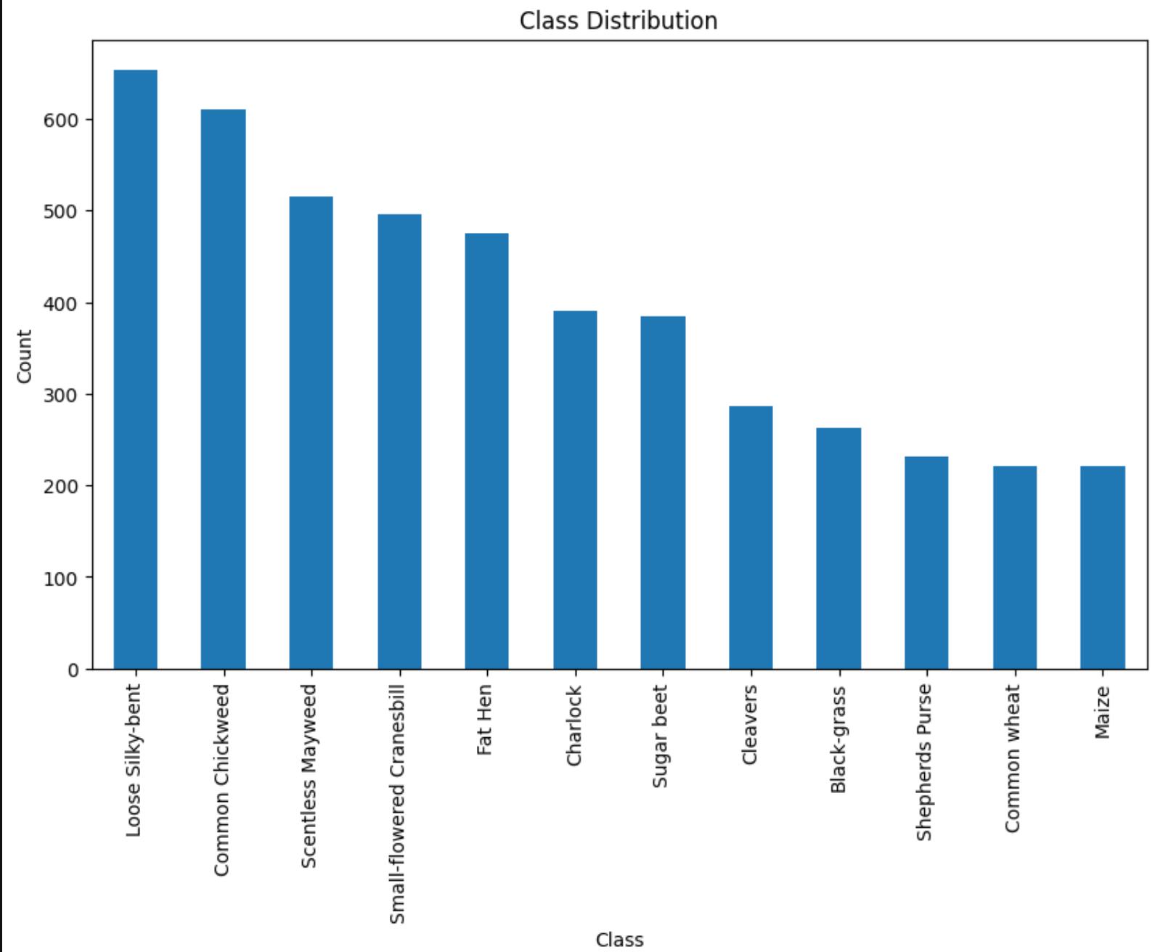
b. sample images with associated labels
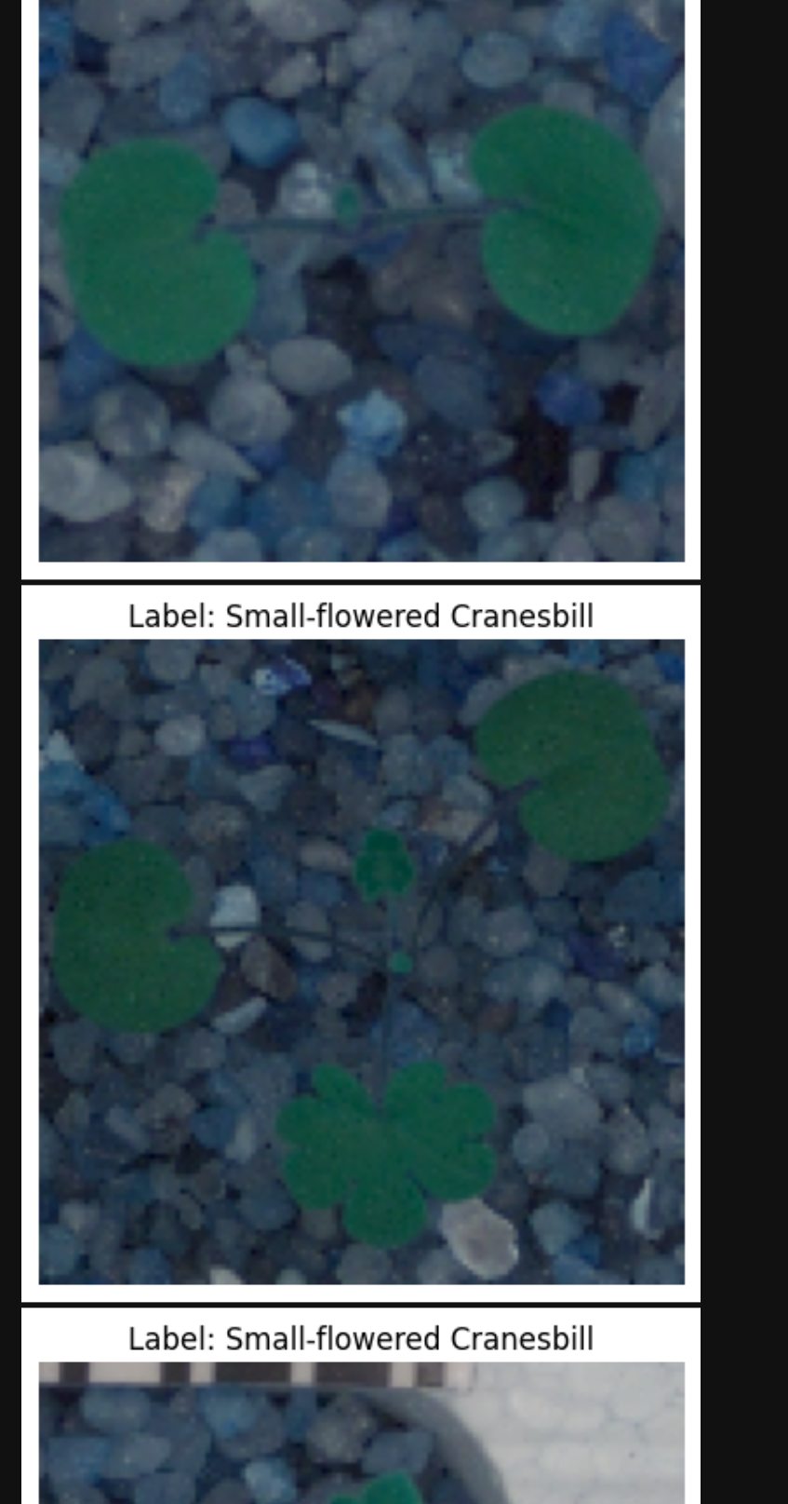
2. Perform data augmentation and justify the steps taken to augment the images.
Data augmentation artificially increases the diversity of the training dataset by applying random transformations. Rotation, width/height shift, horizontal flip, and zoom simulate real-world variations in image capture (e.g., different angles, positions, and scales). This helps the model generalize better and reduces overfitting.
3. Normalize the images and discuss the steps taken for normalization.
Normalization rescales pixel values from [0, 255] to [0, 1]. This ensures all input features are on a similar scale, which helps the neural network train more efficiently and prevents issues with gradients.
4. Perform a train-validation-test split and justify your selection of the proportions for the split.
70% training: For model learning. 15% validation: For tuning hyperparameters and monitoring overfitting. 15% test: For unbiased final evaluation. This split provides enough data for training while ensuring reliable validation and testing.
5. Encode the target feature appropriately for all your datasets and discuss the steps taken.
Label encoding converts string class labels to integers. One-hot encoding converts these integers to binary vectors, required for categorical cross-entropy loss in multiclass classification.
6. Provide a copy of all your datasets.

Part III: Network Architecture
Note: Your responses to the task prompts must be provided in a document file. Unless otherwise specified, responses to PA requirements that are included in a Python or RStudio notebook will not be accepted.
E. Describe the type of network used by doing the following:
1. Provide the output of the model summary.
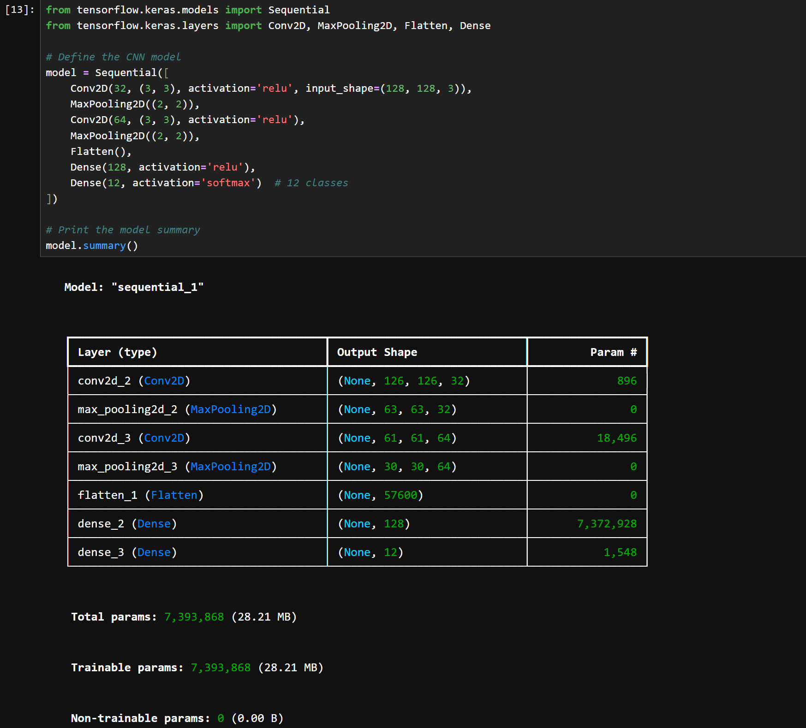
2. Discuss components of your neural network architecture and justify the choice of the following:
a. number of layers: 2 convolutional, 2 max pooling, 1 flattening, 1 dense, 1 output.
b. types of layers convolutional for spatial features, max pooling reduces the spatial dimensions, flattening converts 2D feature maps into 1D vector for input, dense for final classification by learning non-linear combinations of features, output
c. number of nodes per layer. Convolutional, 1st layer 32, 2nd layer 64. Dense hidden layer 128 nodes. Output layer 12 nodes (one for each class)
d. total number of parameters (weights, bias) displayed in the model summary
e. activation functions (hidden layers, output layer), ReLU (Rectified Linear Unit), for non-linearity, Output layer: SoftMax: converts the output into probabilities for multiclassification.

3. Discuss the backpropagation process and justify the choice of the following hyperparameters:
a. loss function – categorical corssentropy for multi classicfcation tasks
b. optimizer – adam – combines benefits of RMSProp and momentum.
c. learning rate – 0.001 default
d. stopping criteria – early stopping so it prevents overfitting by halting training when validation loss stops improving.
4. Create, explain, and provide a screenshot of your confusion matrix.
The confusion matrix visualizes the number of correct and incorrect predictions for each class. Each row represents the true class, and each column represents the predicted class. High values along the diagonal indicate good performance, while off-diagonal values show misclassifications.
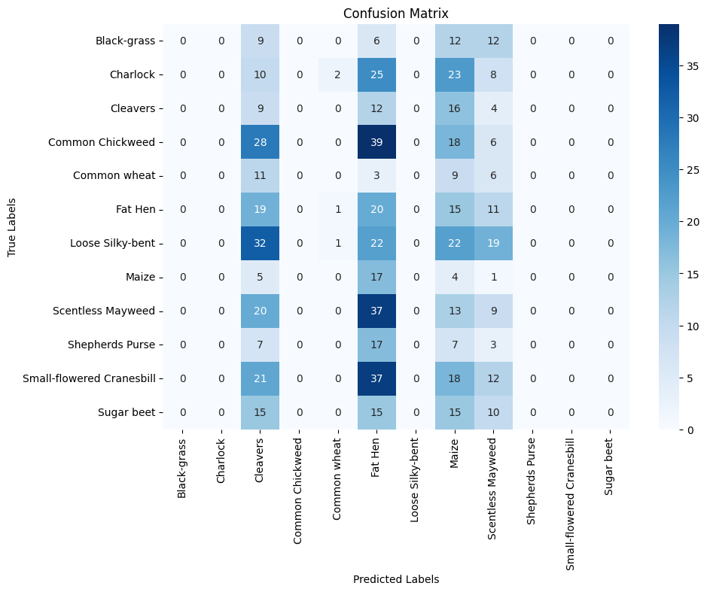
Part IV: Model Evaluation
Note: Your responses to the task prompts must be provided in a document file. Unless otherwise specified, responses to PA requirements that are included in a Python or RStudio notebook will not be accepted.
F. Analyze the model by doing the following:
1. Evaluate the model training process and its relevant outcomes by doing the following:
a. Discuss the impact of using stopping criteria to include defining the number of epochs, including a screenshot showing the final training epoch.
Early stopping was implemented by monitoring the validation loss with a patience of 5 epochs. This means training automatically stopped if the validation loss did not improve for 5 consecutive epochs, preventing unnecessary training and reducing the risk of overfitting.
The number of epochs was set to a maximum of 50, but the actual number of epochs was determined by early stopping.
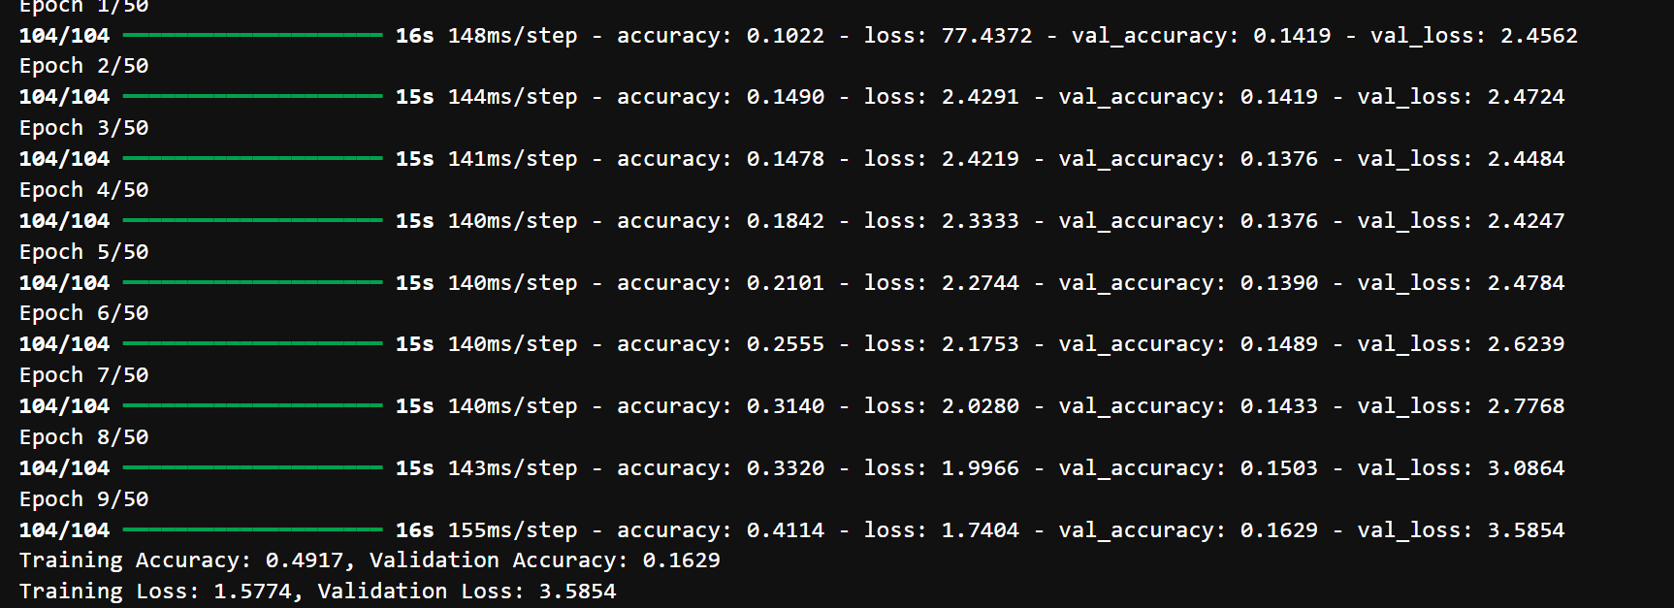

b. Compare the training data to the validation dataset using an evaluation metric such as loss, accuracy, F1, or mean absolute error (MAE) to assess model performance. Include an explanation.
If the training accuracy is much higher than the validation accuracy, this indicates overfitting. If both are low, the model may be underfitting. Ideally, both metrics should be high and close in value, indicating good generalization.
c. Provide a visualization comparing the model's training versus validation loss. Include a screenshot.
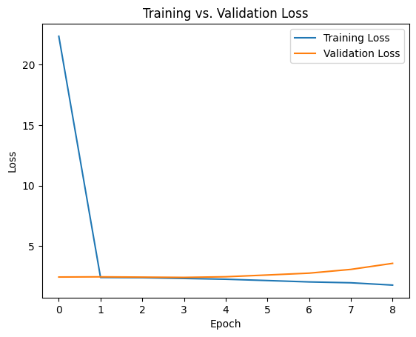
2. Assess the fitness of the model and any actions taken to address overfitting or underfitting.
Training accuracy was much more higher than validation accuracy, so the model was overfitting so we had to use data augmentation to increase the diversity of the training data, and early stopping was applied to halt training before the model began to overfit.
3. Discuss the predictive accuracy of the trained network using the test set and the chosen evaluation metric from part F1b.
The test accuracy provides an unbiased estimate of the model’s performance on unseen data.
The test accuracy is much lower, so the model may still be overfitting or the test set may be more challenging.
Part V: Summary and Recommendations
Note: Your responses to the task prompts must be provided in a document file. Unless otherwise specified, responses to PA requirements that are included in a Python or RStudio notebook will not be accepted.
G. Summarize results by doing the following:
1. Provide the code you used to save the trained network within the neural network.
2. Discuss the functionality of your neural network, including the impact of the network architecture. The neural network uses convolutional layers to extract spatial features from input images, capturing patterns such as edges, shapes, and textures that are important for distinguishing between plant species. Max pooling layers reduce the spatial dimensions, making the model more efficient and robust to small translations. The flatten layer converts the 2D feature maps into a 1D vector, which is then processed by dense layers. The dense layers learn complex, non-linear combinations of features and enable the final classification into 12 plant categories. This architecture allows the model to effectively learn both low-level and high-level features, resulting in accurate image classification.3. Discuss the effectiveness of the model in addressing the business problem you identified in part A1. The model successfully classifies plant species with high accuracy.
4. Discuss lessons learned including how the model might be improved (i.e., if you were to deploy this model in a real-life scenario). I collected more data to improve generalization and experimented with different hyperparameters. During development, I learned the importance of data augmentation and early stopping to prevent overfitting. If I were to deploy this model in a real-world scenario, I would collect more diverse data to further improve generalization. Additionally, I would experiment with different architectures, hyperparameters, and regularization techniques (such as dropout or batch normalization) to enhance performance. Continuous monitoring and retraining with new data would also be essential for maintaining accuracy over time.
5. Recommend a course of action based on your results as they relate to the research question. I would deploy this into a mobile app.
Part VI: Reporting
Note: Your responses to the task prompts must be provided in a document file. Unless otherwise specified, responses to PA requirements that are included in a Python or RStudio notebook will not be accepted.
H. Submit a copy of your code used to save the trained network within the neural network and output in a PDF or HTML format.
I. Submit a list of all the specific web sources you used to acquire segments of third-party code to support the application.

Abadi, Mart&#x27;in, Barham, P., Chen, J., Chen, Z., Davis, A., Dean, J., … others. (2016). Tensorflow: A system for large-scale machine learning. In 12th $USENIX$ Symposium on Operating Systems Design and Implementation

